EXHIBIT A
Legal Description
475 Graves Creek Rd
Cottonwood, ID 83522
Idaho County ID

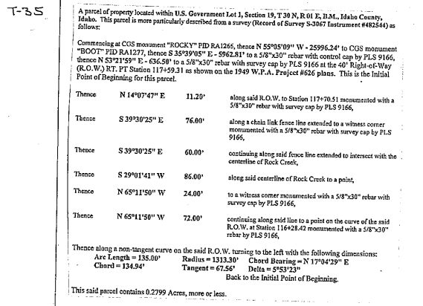

&

T30N R1E SEC 19 3.749 AC LOT 1 E OF RD & W OF ROCK CRK LESS TAX 35 & 46

